LESSON PLAN

DATE:
SCHOOL:
TEACHER : Aramă Păsălău Carmen
Grade: 6th L1
Textbook: Right On 2, Uniscan Express Publishing, Jenny Dooley
UNIT 1: My World
LESSON: My World
CONTENT: appearance
LESSON TYPE: mixed (COMPUTER LAB ENGLISH LESSON)/ speaking, writing, watching.

MAJOR OBJECTIVES:
  - the development of the reception of oral messages
  - the tracing out of the global meaning of oral messages
2.1. the development of the capacity to express orally
2.2. the reproduction of short oral messages
3.1. the development of the tracing out capacity in a written text
3.2. the tracing out of the global meaning in a written text
4.1. the development of the writing expression
4.2. the drafting of short enunciations, based on verbal support or images

REFERENCE OBJECTIVES:
- KNOWLEDGE:
To know and use the appearance items in oral and writing.
- MOVEMENT:
a) students have to react promptly
b) students have to coordinate their movements to solve the exercises
- EMOTIONAL ASPECTS:
- to comply with the teacher`s explanations
- to depict the meanings of the words used in exercises

RESOURCES:

- BIBLIOGRAPHICAL:
- Dicţionar englez- român, român- englez, Andrei Bantaş,
- Dicţionar Oxford Explicativ ilustrat al limbii engleze, Dorling Kindersley, London, OUP, New York, Litera Intenaţional, Bucureşti
- Textbook: Right On 2, Uniscan Express Publishing, Jenny Dooley
- Limba engleză. Caiet de lucru pentru clasa a VI-a, Liliana Putinei, Cristina Mircea, Ed. Booklet
- dictionary.reference.com
B. METHODICAL:
Computer lab (computers, headphones)
video projector
notebooks

C. TEMPORAL: 50 min.
D. HUMAN: all the students in the class.

STAGE | STUDENTS’ ACTIVITIES | INTERACTION | SKILLS | TIME | PURPOSE
1. WARM-UP | - Revise the words about family | T-Ss | Speaking | 3 min. | To stir the Ss’ interest for the subject
- EXERCISES ON COMPUTERS IN THE LAB | - Interactive matching exercise  Created by me on HotPotatoes 6 software  Match the items on the right to the items on the left.  The categories are height, build, age, general appearance  (ex.4/ page 17) | Ss-Ss | Writing, working on computers | 5 min. | To evaluate the students skills to find categories
 | - Interactive gap-fill exercise  Created by me on HotPotatoes 6 software  An exercise about 4 people, based on the exercise 6a/page 17-18 in Limba engleză. Caiet de lucru pentru clasa a VI-a, Liliana Putinei, Cristina Mircea, Ed. Booklet | Ss-Ss | Writing, working on computers | 5 min. | To evaluate the Ss skills to find the meaning of the words
 | - My World Interactive Quiz  Created by me on HotPotatoes 6 software  Students will click on the link with the video in the quiz and then choose the right answers for the quiz  The quiz is from the textbook Right On 2, Uniscan Express Publishing, Jenny Dooley | Ss-Ss | Watching  Listening  working on computers | 15 min. | To evaluate Ss skills to check the understanding of the meaning in the video watched
FEEDBACK | Short feedback on INSIGHT TEACHER  (SPEECH TO TEXT exercise to test pronunciation) | Ss’ microphones | Writing | 2 min.

Right On 2 INT – Exercises – Thinks

M1p10_My World

Circle the correct answer A or B.

1 Emma has got
A short brown hair and brown eyes.
B long straight hair and brown eyes.

2 Kate is tall and she’s got
A glasses.
B wavy blonde hair.

3 Mr Jones wears a smart shirt and
A tie to work every day.
B trousers to work every day.

4 When we see Alex, he’s wearing a
A stripey hoody.
B checkered shirt.

5 Jane’s got wavy blonde hair and she’s
A very confident.
B quite shy.

6 While Emma is doing her homework, her mum is
A cooking dinner.
B cleaning the kitchen.

Right On 2 INT – Key – Think! Suggested answers

M1p10_My World

Key
1 B, 2 A, 3 B, 4 B, 5 A 6 A

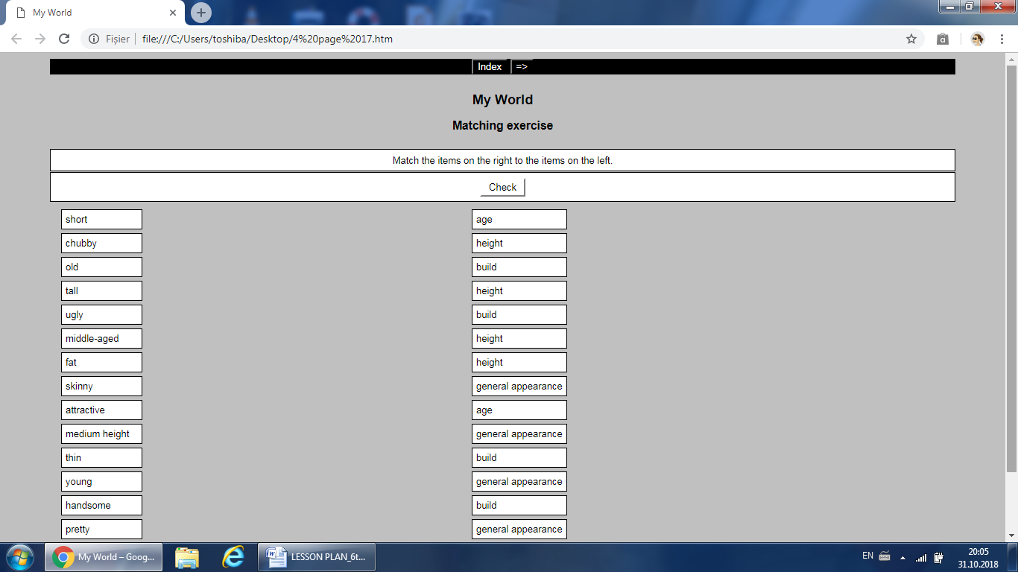

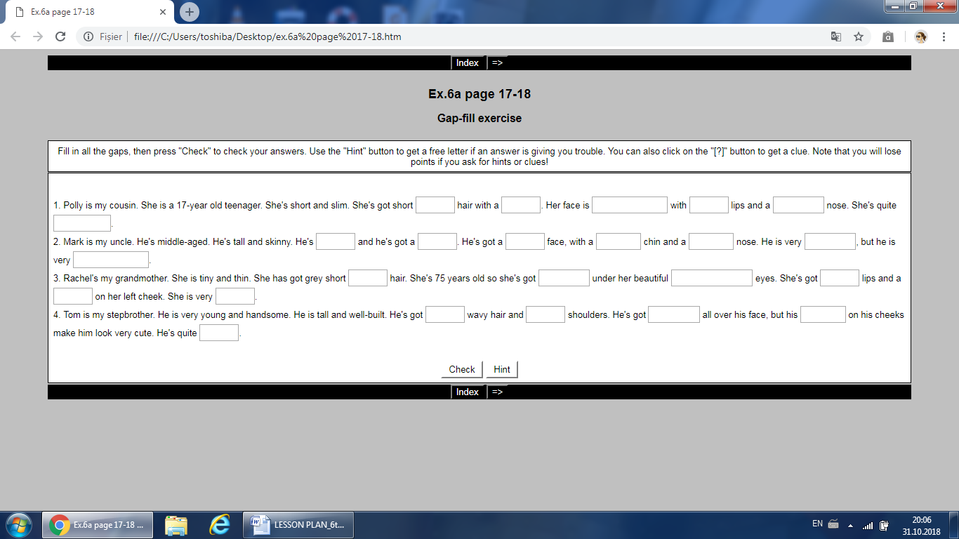

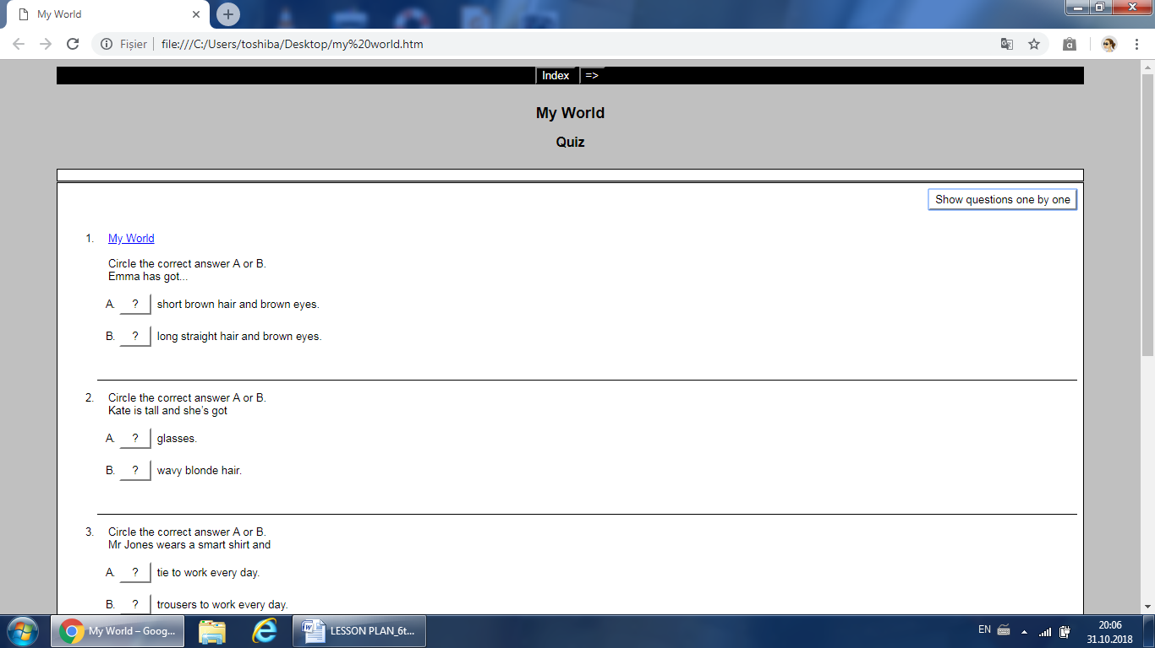

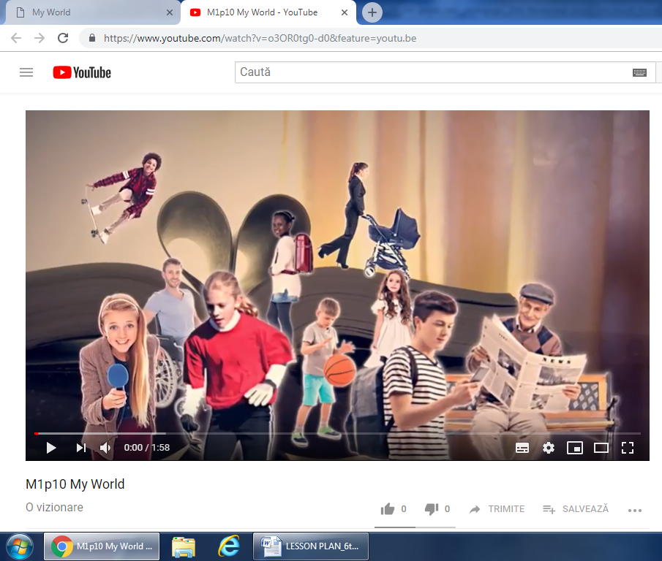

My Family
Grandfather, grandpa= bunicul; Grandmother, grandma= bunica
Mother, mum= mama; Father, dad= tata
Child, children= copil, copii; Son= fiu; Daughter= fiica
Sister= sora; Brother= frate; Siblings= frati, surori
Aunt= matusa; Uncle= unchi
Cousin= var, verisoara
Grandchildren= nepoti (dupa bunici); Granddaughter= nepoata (dupa bunici), grandson= nepot (dupa bunici)
Nephew= nepot (dupa unchi); Niece= nepoata (dupa unchi)
Sister-in-law= sora vitrega; cumnata; stepsister/brother= frate/sora vitrega
Mother-in-law= mama vitrega; soacra
Husband= sot; Wife= sotie

Appearance
Short/long hair; straight (drept)/ wavy (ondulat)/ curly (carliontat); black/ dark (negru)/ fair (blond)/ red/ brown hair
Blue/ green/ black/ brown eyes
Young= tanar; old= batran
Short= scund; tall= inalt; medium height= inaltime medie
Fat= gras; chubby= dolofan; slim/ thin= slab
Moustache= mustata; beard= barba; glasses= ochelari

